PYTHON MODULE 2
1.Python Program to find the sum of series 1^2+2^2+3^2...+N^2.
For example:
Input | Result
2 | The sum of the series = 5

PROGRAM:
a=int(input())
i=0
c=0
sum = 0
for i in range (1,a+1):
c=i**2
sum=sum+c
i=i+1
print("The sum of the series = ",sum)

RESULT:

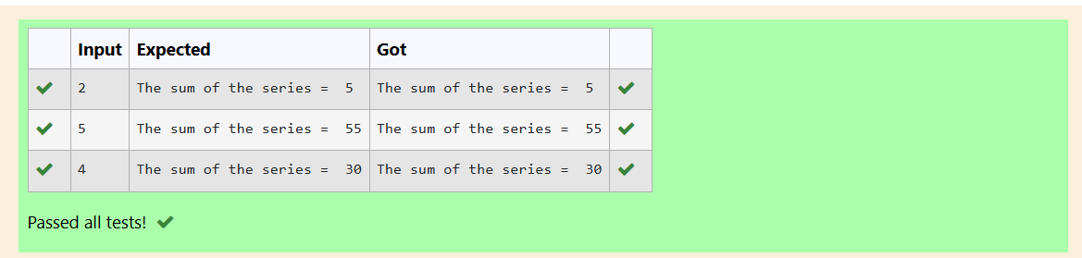

2. Python Program to check if a number is a Perfect number using the concept of functions.
For example:
Input | Result
6 | The number is a Perfect number!

PROGRAM:
a=int(input())
sum=0
for i in range (1,a):
if(a%i==0):
sum=sum+i
if sum==a:
print("The number is a Perfect number!")
else:
print("The number is not a Perfect number!")

RESULT:
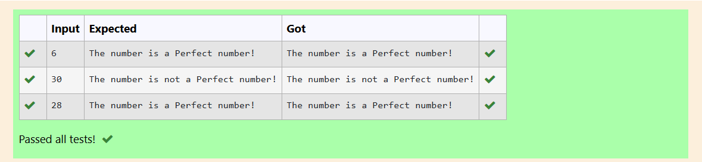

3. Write a function which takes three arguments: a and b and c and returns the multiplication of them: a*b*c. Assign it to a variable named: f. using python
For example:
Input | Result
10  20  30 | 6000

PROGRAM:
a=int(input())
b=int(input())
c=int(input())
f=lambda a,b,c:a*b*c
print(f(a,b,c))
RESULT:
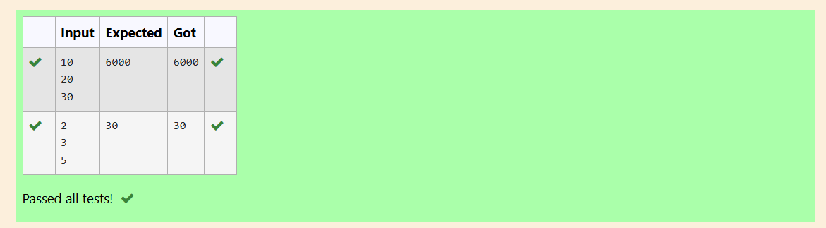
4. Python program to print alternate number pattern .Get the number of rows as input
For example:
Input | Result
5 | 1  3 3  5 5 5  7 7 7 7  9 9 9 9 9

PROGRAM:
a=int(input())
for i in range(1,a+1):
b=2*i-1
for j in range(1,i+1):
print(b,end=" ")
print()
RESULT:
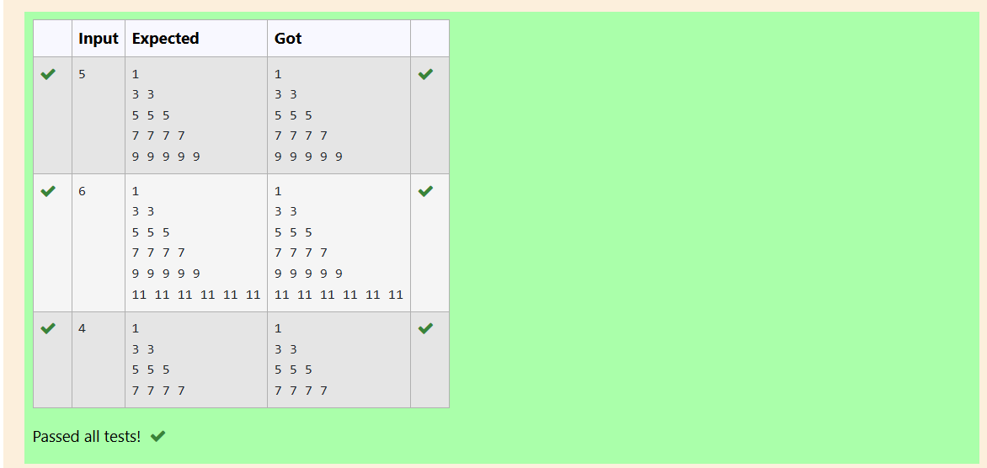
5. Write Python program to print reverse Pyramid of numbers.Get the number of rows as input.

For example:
Input | Result
6 | 1  2 1  3 2 1  4 3 2 1  5 4 3 2 1

PROGRAM:
a=int(input())
for i in range(1,a):
for j in range(i,0,-1):
print(j,end=" ")
print()
RESULT:
